Armenian Heritage Park on the Greenway ‘A Living Piece of Art’
AUGUST 23, 2018

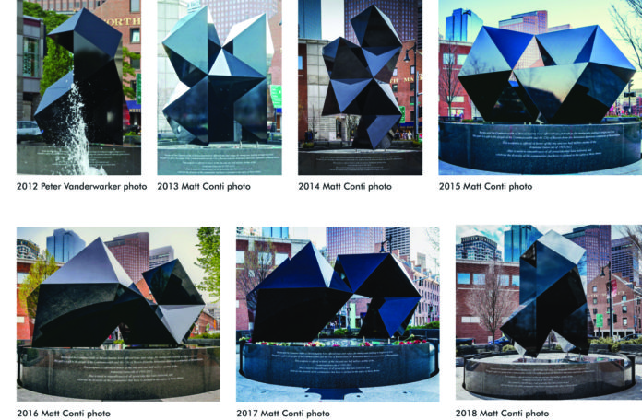

BOSTON — The annual reconfiguration of Abstract Sculpture heralds the start of a new year of programs at Armenian Heritage Park on Boston’s The Greenway. This annual reconfiguration is symbolic of the immigrant experience, all of whom pulled away from their countries of origin and came to these shores, establishing themselves in new and different ways. In the early Spring, a crane lifts and pulls apart the two halves of the split rhomboid dodecahedron, made of steel and aluminum, to create a new sculptural shape. The park’s Charles G. and Doreen Bilezekian Endowed Fund supports the annual reconfiguration. A&A Industries, led by Anahid and Aurelian Mardiros, which fabricated the abstract sculpture, their very generous gift-in-kind, oversees the annual reconfiguration. Each configuration is detailed in the manual prepared by the park’s architect/designer.
The abstract sculpture is dedicated to lives lost in the Armenian Genocide of 1915-23 and all genocides that have followed. How fitting, that programs at the park begin in April with the Genocide Commemoration, planned by the Boston Armenian Genocide Committee and also the Walk Against Geocode, planned by the Massachusetts Coalition to Save Darfur, which begins at the Holocaust Memorial and ends at the Park.
Programs during May showcase the Park’s two features, the Abstract Sculpture and Labyrinth, a circular winding path to celebrate life’s journey. A single jet of water at its center, representing hope and rebirth, reemerging from the Reflecting Pool upon which the Abstract Sculpture sits; Art, Service, Science, Commerce etched around its circle in tribute to contributions made to American life and culture.
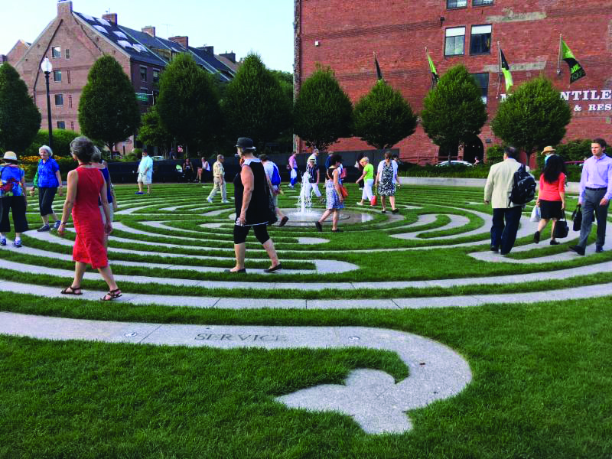
The two-part ArtWeek Boston featured program on the first Saturday in May begins with World Labyrinth Day: Walk As One at 1, with all ages participating in cities and towns in 35 countries worldwide. For the first time, Gyumri, Armenia’s second largest city, joined this international initiative of The Labyrinth Society.
A reception to view the abstract sculpture’s new configuration follows the walk. Sarah Baker, Art New England editor, offered brief remarks including “I love this sculpture… this living piece of art.” Tea and Desserts were hosted by Eastern Lamejun Bakers and MEM Tea Imports.

Tea & Tranquility, the late afternoon monthly summer series, continues to bring people together to meet and greet, walk the labyrinth and enjoy ice teas and desserts, hosted by the MEM Tea Imports and The Bostonian Hotel.
Under A Strawberry Moon, a first-time evening event in June, had it not been for the downpour, would have featured chocolate-dipped strawberries, hosted by Vicki Lee’s. Many programs at the park not supported by one of the park’s endowed funds, depend on the generosity of gifts-in-kind.
“Today we are celebrating what binds us together. This togetherness, this celebration and the embrace of our difference, is how we not only survive but thrive”, shared Tania Del Rio, executive director, City of Boston Office of Women’s Advancement, during brief remarks at the park to launch Celebrating What Unites Us!
This new collaborative initiative celebrates the immigrant experience while building community and cross-cultural understanding. The innovative, monthly program is collaborative initiative of the City of Boston, Age-Friendly Boston, Mayor’s Office for Immigrant Advancement, The KITCHEN at Boston Public Market, Blue Cross Blue Shield of Massachusetts and Friends of Heritage Park.
Each month participants first meet and greet at the Park where a community leader shares his/her immigrant experience. All walk the labyrinth, many for the first time, and then walk to The KITCHEN at the Boston Public Market where a Boston chef prepares a signature seasonal dish celebrating his/her heritage for participants to enjoy for lunch and conversation. Leo Romero, Chef/Owner, Casa Romero, prepared signature dishes for the June program. Nina Festekjian, chef/owner, anoush’ella a saj kitchen is the featured chef at THE KITCHEN for October’s Celebrating What Unites Us!
Nina and Raffi Festekjian, owners of anoush’ella in Boston’s South End, are among the park’s major benefactors.
Under the August Moon, a first-time evening event at the Park for supporters, partners, and friends will also feature anoush’ella signature tastings. During the August 23 evening, all will also enjoy refreshing ice teas hosted by MEM Tea and cool sounds of the Berklee All-Star Jazz Ensemble while meeting and greeting. Advance reservations are required.
Middlesex County Sheriff Peter Koutoujian welcomes new US citizens.
Welcome Reception for New Citizens, Their Families and Friends at the Park, supported by the Park’s Anna and Noubar Afeyan Endowed Fund, follows the Naturalization Ceremony at Faneuil Hall on September 13. “By appealing to a range of new American citizens, the Welcome Reception contributes decisively to the Armenian Heritage Park’s core mission of inclusion,” comments Armine Afeyan, founding chair, Welcome Reception. “As a celebration of the immigrant experience in Boston, the Welcome speaks directly to central themes of the Park and the Rose Kennedy Greenway. The Welcome acknowledges the history of Boston as a port of entry for immigrants worldwide and celebrates those who…contribute to the richness of American life and culture,’ which is the Park’s intent.”
The Welcome Reception is offered in partnership with City of Boston/Office of Immigrant Advancement, International Institute of New England, Irish International Immigrant Center, Project Citizenship, Museum of Fine Arts Boston, The Bostonian Society, Armenian Museum of America, Greenway Conservancy among others.
Geometry as Public Art: Telling a Story, a newly developed school-based curriculum, has been inspired by the Park and its two features. The intent of the curriculum is to spark greater awareness of geometric shapes as a creative expression of ideas and thoughts and to celebrate what unites us and connects us — the immigrant experience, while building common ground. This September The Eliot K-8 Innovation School, Boston Public School in the North End will continue to pilot the curriculum. The Boston Public Schools has requested that the curriculum be made available to all schools.
Cindy Fitzgibbon, WCVB-TV5, is emcee for Sunday Afternoon for Families and Friends on September 16 with live music, dancing, face painting and games for all ages. This year features the music of Boston Hye Guys Ensemble.
This year’s HUBweek featured program, Walking the Labyrinth: Reducing and Managing Stress, is on Tuesday, October 9, with a reception following at Hollister Staffing, 75 State Street.
The annual Najarian Lecture on Human Rights at Faneuil Hall, supported by the Park’s K. George and Carolann S. Najarian, M.D. Endowed Fund, is on November 14. “Incarceration: Untangling the web of injustice” is this year’s topic. Featured speakers are Andrea Cabral, former Massachusetts Secretary of Public Safety and author, Enforcing and Defending Chapter 209A Restraining Orders in Massachusetts; Marc A. Levin, Director, Center for Effective Justice and the Right on Crime, an initiative of the Texas Public Policy Foundation with moderator Sheriff Peter J. Koutoujian, Sheriff of Middlesex County and President, Massachusetts Sheriffs’ Association. The purpose of the Najarian Lecture on Human Rights is to advance understanding of human rights issues and the societal abuses worldwide, and to increase awareness of the work of individuals and organizations so that we are all more actively involved. A reception follows at The Bostonian Hotel.
“Boston’s Newest Holiday Tradition” (METRO), the Candlelit Labyrinth Peace Walk on December 16 perfectly wraps the year-long series of programs and events.
For further information, visit ArmenanHeritagePark.org and follow us on social media or email us hello@ArmenianHeritagePark.org.

