Boston Celebrates Immigrants in New Event Series Sara Brown 8.22.18
On a bright, beautiful morning Boston residents gathered at the Armenian Heritage Park for “Celebrating What Unites Us,” a program that celebrates immigrants and what they contribute to the city.
This was the third event in an eight part series. Each event focuses on a different immigrant community. This past Monday the focus was on Dominicans. There are about 18,743 Dominicans in the city of Boston. About 60 percent of them are female and most of them work in the labor force
The festivities started with participants gathering at the park to meet Alexandra Valdez, who works in the Mayor’s office as a Latino liaison.
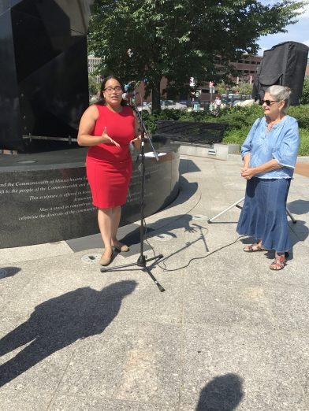

Valdez moved to this country from the Dominican Republic when she was 10 years old. One of her first vivid memories of when she arrived in Boston was seeing the Prudential building for the first time.
“I remember thinking it was so big,” she said. “My dad drove me around the city so I could look at the rest of the tall buildings.”
Valdez didn’t know a word of English when she arrived and admits the transition was hard. She often told her parents she wanted to move back to the DR.
“I felt isolated from my classmates,” she said about first attending school in Boston.
However, Valdez persevered and attended Mass Bay Community College for two years. Afterwards, she received a full scholarship to Fitchburg College where she studied communications. She was the first in her family to attend college.
She now works in the Mayor’s office interacting with immigrants everyday.
“When I think about where I came from and where I started and where I am today, it’s insane,” she said. “It’s crazy. It’s a dream come true.”
She admits she is always learning and improving. “Everyday is a learning process,” she said.
Afterward, participants walked the labyrinth, symbolic of life’s journey, and as a way to quiet the mind and reduce and manage stress.
Following that, participants walked over to The KITCHEN at the Boston Public Market. Following an introduction by The Trustees on the benefits of seasonal eating, Boston Chef Giovanna Huyke, FABRICA demonstrated a signature seasonal dish celebrating his cultural heritage for participants to then enjoy for lunch.

Celebrating What Unites Us was developed by the Boston Elderly Commission’s Age-Friendly Boston, The KITCHEN at Boston Public Market (operated by The Trustees), and Friends of Armenian Heritage Park on The Greenway in collaboration with the Mayor’s Office of Food Access and the Mayor’s Office for Immigrant Advancement. RSVP for future events her

